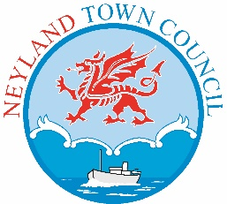
10th August, 2022.
Dear Member,

A meeting of the Planning Committee will be held on Monday 22nd August, 2022, in Neyland Community Hub, Neyland SA73 1TH at 6.30pm. Should you wish to attend remotely please contact the Town Clerk for a link.

Yours faithfully

Vanessa Walker

Vanessa Walker
Deputy Town Clerk/Financial Officer

A G E N D A

- To nominate a Chair for the meeting.
- To receive apologies for absence.
- To receive Declarations of Interest.
- To consider the following planning applications:
Please access the links for details of plans etc.
- 22/0355/PA: Land at former Roman Catholic Church, Church Way, Neyland, SA73 1UE - Erection of four semi-detached dwellings together with vehicular access and parking (alternative to scheme and commenced development under reference 07/0128/PA)
WPHAPPDETAIL (pembrokeshire.gov.uk)
- 22/0295/PA: The Old Public Convenience, The Promenade, Neyland, Milford Haven - Conversion of the Old Public Convenience into a one-bedroom holiday let.
WPHAPPDETAIL (pembrokeshire.gov.uk)
- 22/0353/PA: 5, Picton Road, NEYLAND, Milford Haven, Pembrokeshire - Conversion of redundant hotel and manager's flat into 3 No self-contained apartments
WPHAPPDETAIL(pembrokeshire.gov.uk)
- 22/0208/PA: 65, High Street, NEYLAND, Milford Haven, Pembrokeshire, SA73 1TE. Change of use from A1 to C2.
WPHAPPDETAIL (pembrokeshire.gov.uk)

- To receive the following Planning Decision
21/1128/CA: Pavilion House, 44, John Street, NEYLAND, Milford Haven, Pembrokeshire, SA73 1TH. Conditionally approved.
- Any other planning matters.

